Serial No: 1 | Name of the Assignment: Identify whether a given line is a comment
Implementation Code snippet:
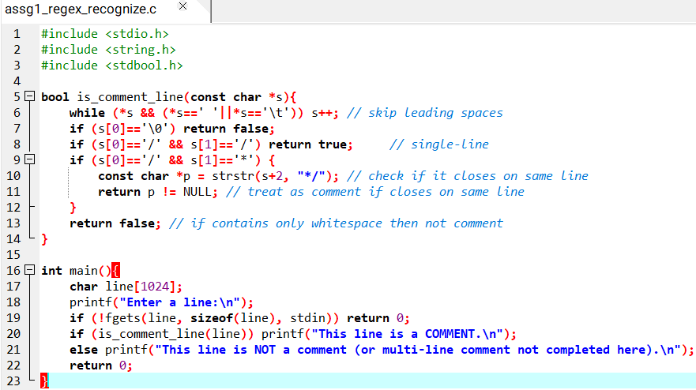
Obtained Output:
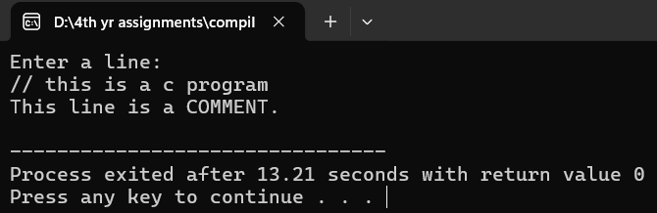
Discussion: It is a C program to identify whether a line is a comment.

Serial No: 2 | Name of the Assignment: Recognize strings under 'a', 'a*b+', 'abb'
Implementation Code snippet:
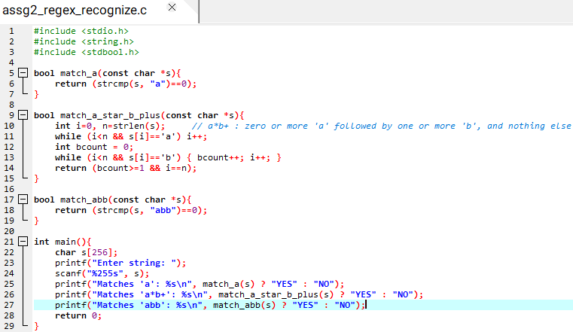
Obtained Output:
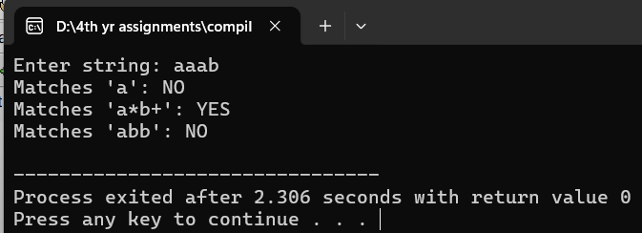
Discussion: It is a C program to recognize strings like a, a*b+, abb.

Serial No: 3 | Name of the Assignment: Test whether a given identifier is valid
Implementation Code snippet:
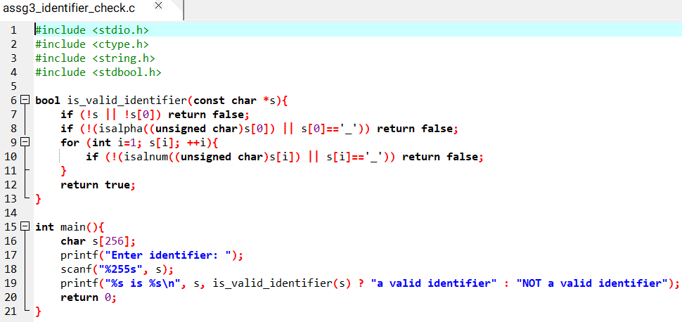
Obtained Output:
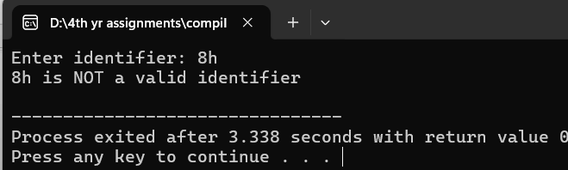
Discussion: It is a C program to test whether an identifier is valid.

Serial No: 4 | Name of the Assignment: Simulate lexical analyzer for validating operators
Implementation Code snippet:
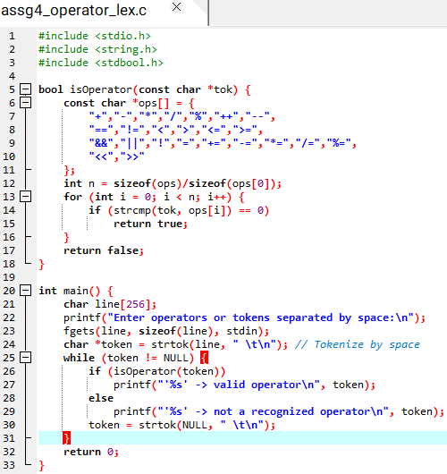
Obtained Output:
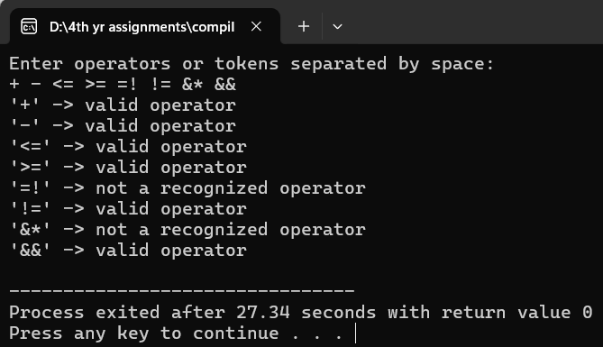
Discussion: It is a C program to simulate lexical analyzer for validating operators.

Serial No: 5 | Name of the Assignment: Design context free grammar for the given language
a) Construct LL(1) parsing
b) Construct recursive descent parsing
Implementation Code snippet:
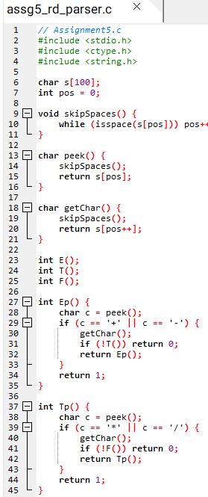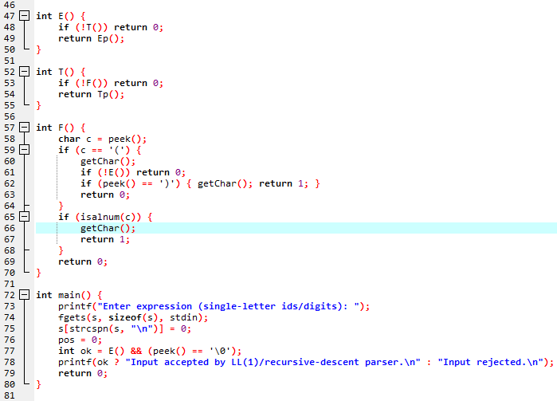
Obtained Output:
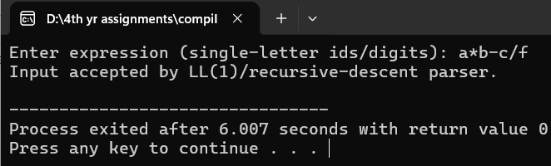
Discussion: It is a C program implementing LL(1) and recursive descent parsing grammar.

Serial No: 6 | Name of the Assignment: Design an LALR grammar and implement LALR parsing
Implementation Code snippet:
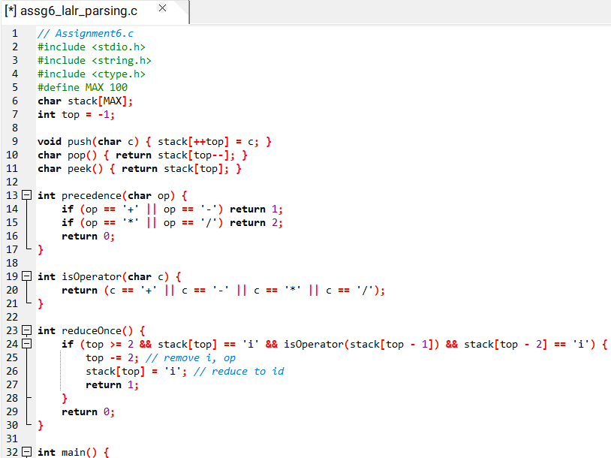
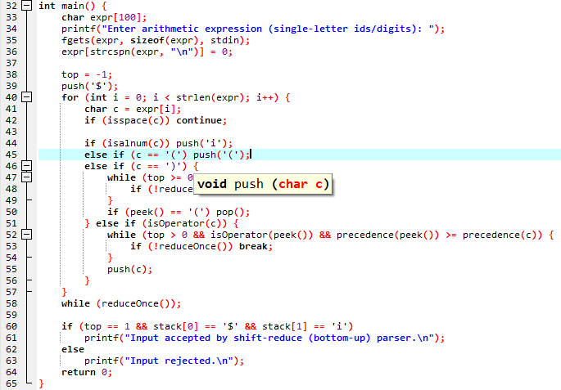
Obtained Output:
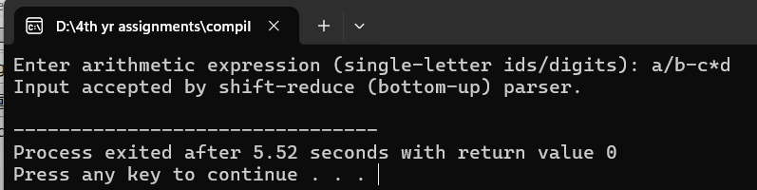
Discussion: It is a C program demonstrating LALR parsing using bottom-up approach.

Serial No: 7 | Name of the Assignment: Check whether variable values stored in variables are mapped to appropriate datatypes
Implementation Code snippet:
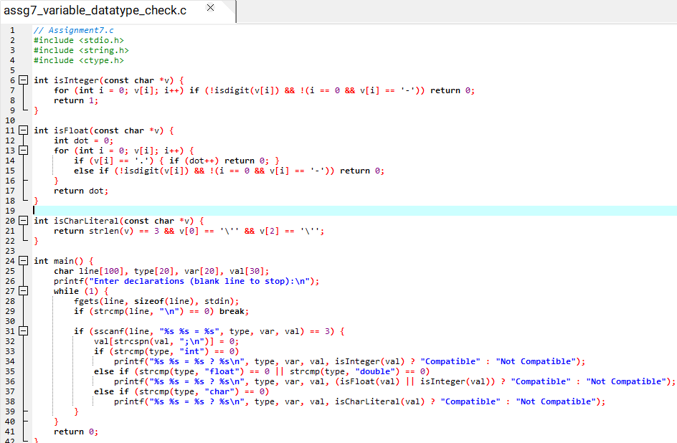
Obtained Output:
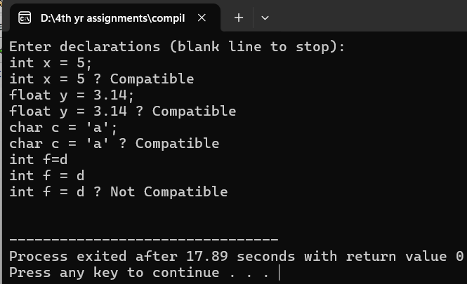
Discussion: It is a C program checking variables mapped correctly to their datatypes.

Serial No: 8 | Name of the Assignment: Detect undeclared variables
Implementation Code snippet:
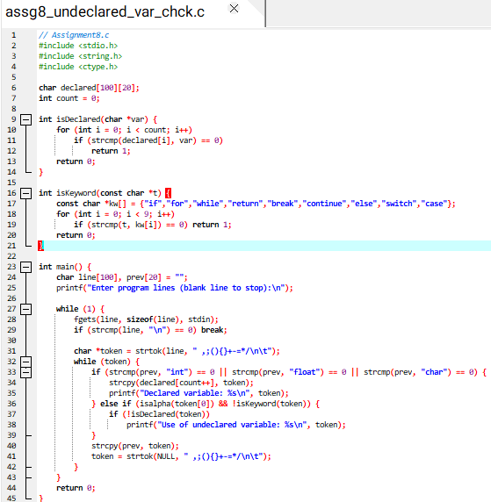
Obtained Output:
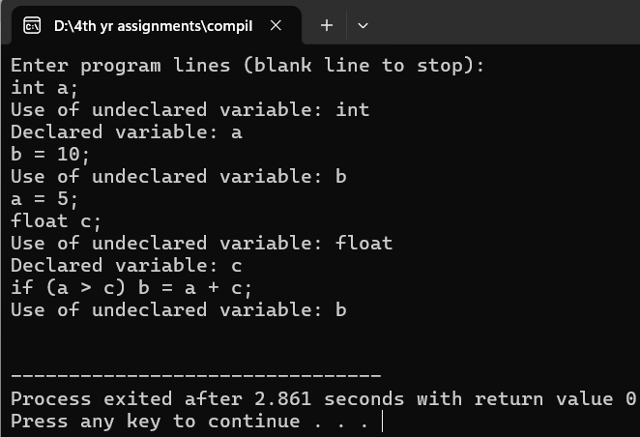
Discussion: It is a C program to detect use of undeclared variables.

Serial No: 9 | Name of the Assignment: Check whether the break keyword has been used outside any loop
Implementation Code snippet:
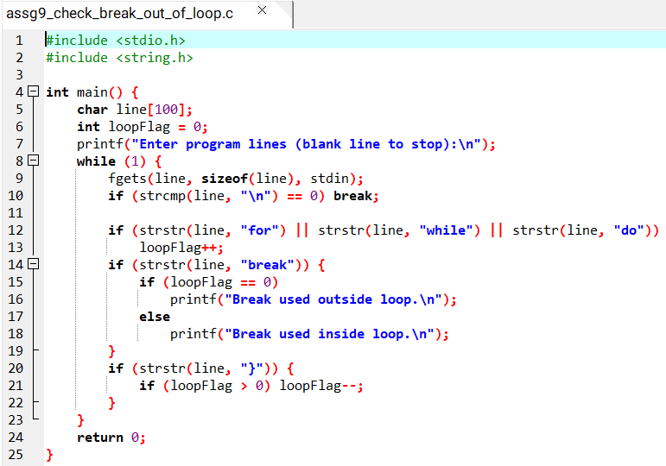
Obtained Output:
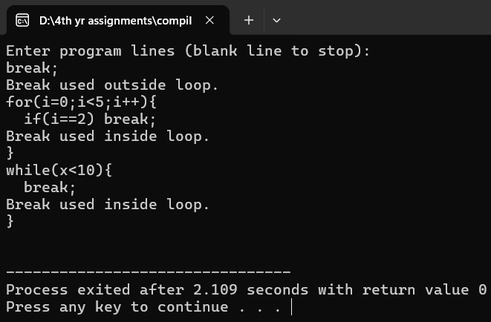
Discussion: It is a C program to check misuse of break statement outside loops.

Serial No: 10 | Name of the Assignment: Create a parse tree
Implementation Code snippet:
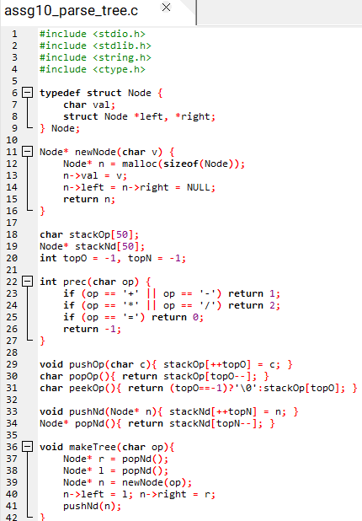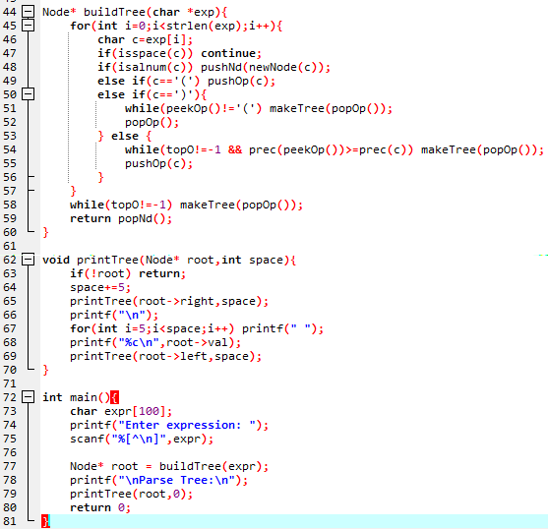
Obtained Output:
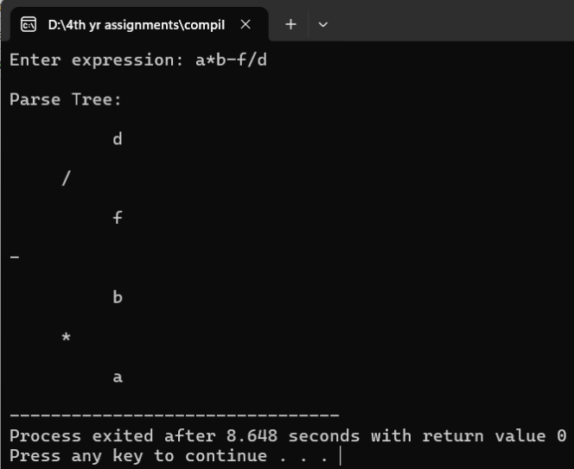
Discussion: It is a C program to create and print a parse tree clearly.

Serial No: 11 | Name of the Assignment: Generate three address code
Implementation Code snippet:
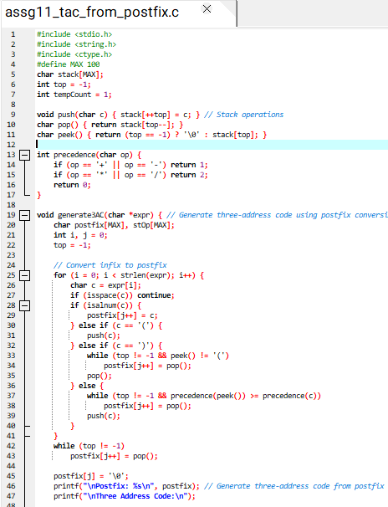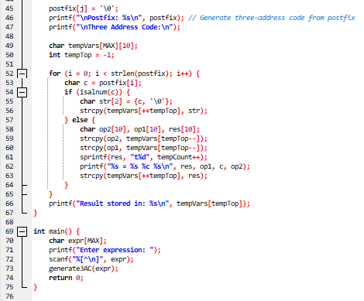
Obtained Output:
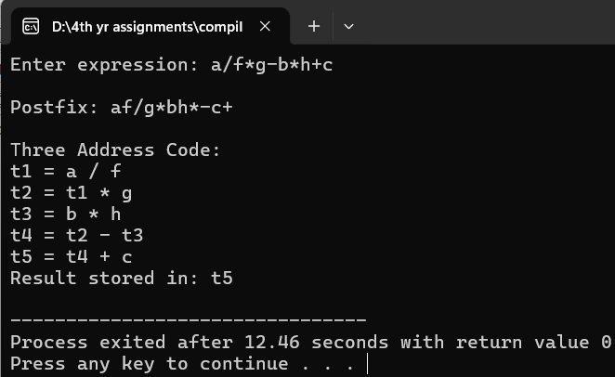
Discussion: It is a C program to generate three address code for expressions.
Serial No: 12 | Name of the Assignment: Generate postfix representation
Implementation Code snippet:
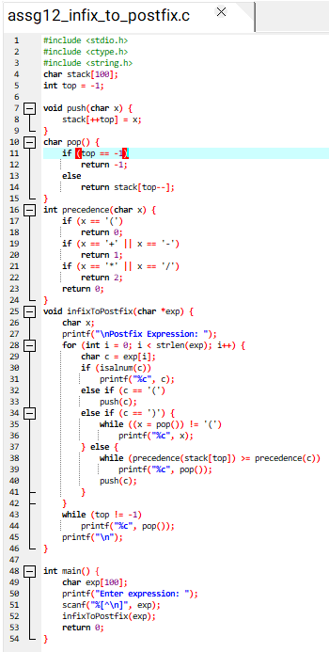
Obtained Output:
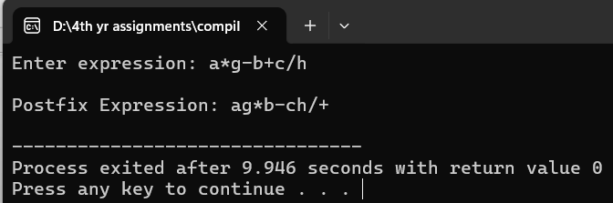
Discussion: It is a C program to generate postfix notation of given arithmetic expressions.

